7th Heaven Animal Rescue Trust
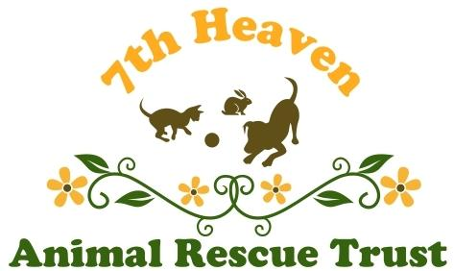
Trustees’ Annual Report
1 April 2022 to 31 March 2023

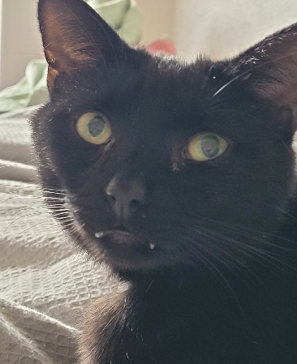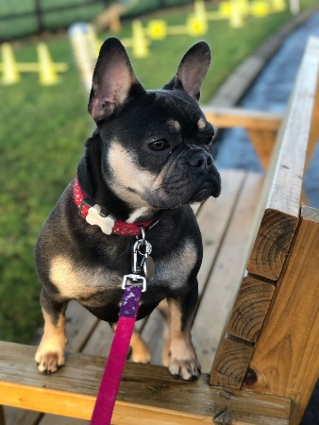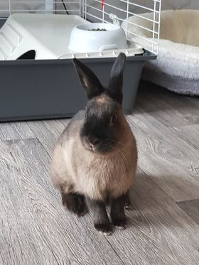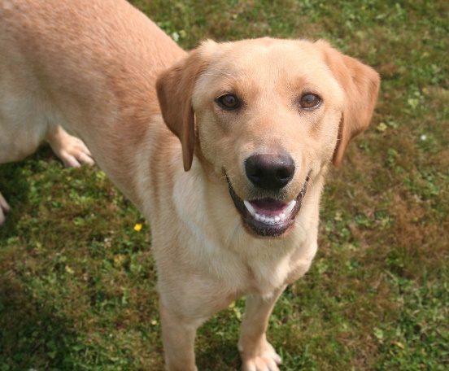

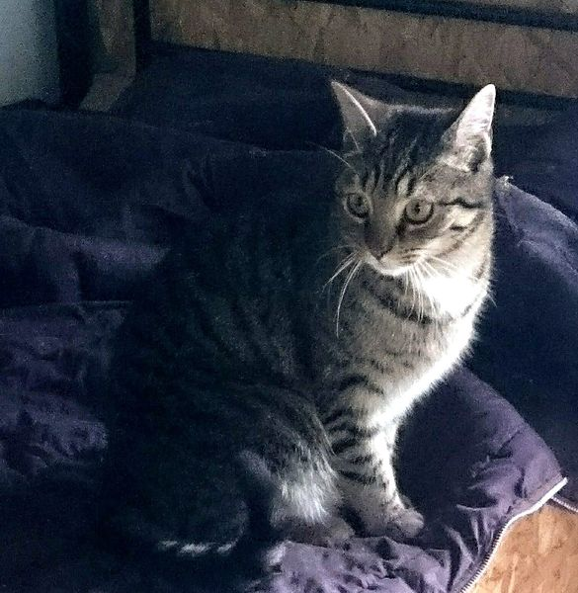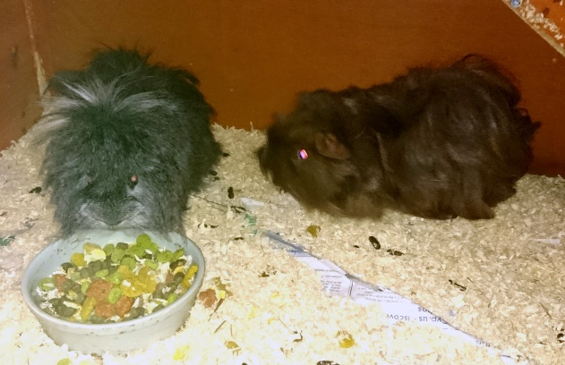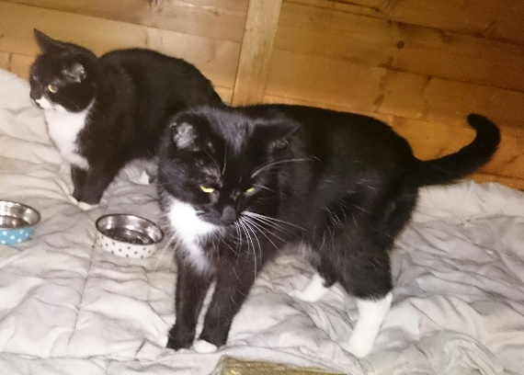

(Some of the animals rehomed 2022-2023)

Charity Registration in Northern Ireland: NIC101696
HMRC Registration: XR65507 (March 2003)
7TH Heaven Animal Rescue Trust
Registered address:
PO Box 198, Newtownabbey, BT36 9BP
www.7thheaven.org.uk

Structure, governance and management
Nature of governing document
7th Heaven Animal Rescue Trust, which is also recognised as a charity by HM Revenue and Customs in Northern Ireland, is operated under the rules of its Trust Deed dated 24 March 2003.

Organisational structure
The Trust is governed by the Trustees.
A new Trustee may be appointed by resolution of a meeting of all the Trustees, passed by a majority of those present
Trustees:
Mrs Heather McMurray: Chair
Mr Stephen McMurray: Treasurer
Mrs Lorna Peppiatt: Secretary

Objectives
The Charity is established for the protection of all small domestic animals from abuse, neglect and distress by providing for their care and treatment in a safe environment with the aim to rehoming and in particular:
- A No Kill policy will operate except when an animal is suffering unnecessarily and when no further treatment is available and only following consultation with a veterinary surgeon and permission of 2 trustees
- To provide or make arrangements for the provision of animals which cannot be rehomed

Achievements and Performance 2022 / 2023
7th Heaven has continued to be inundated with requests to help the abused, neglected, distressed, unwanted or abandoned animals throughout Northern Ireland.
We can’t help them all, but we will always try to take in, care for and re-home as many as possible. We also offer help through our various schemes and provide advice where we can. We hope that in doing so, we will be promoting compassion and empathy in the public, whilst also giving a sense of companionship and well-being to those recipients of the re-homed animals and relief through the support we offer.

- 7th Heaven's 20th Anniversary 31 March 2023.
We can't believe how time has flown since we started the charity 20 years ago. Many animals have been rescued and rehomed. We have set up several schemes to help animals in need- our Pet Food Bank, Project Wildcat scheme, Made in Heaven Matchmaking Service, Landlord scheme; Dog Training scheme; Daisy Day, Feral Cat month. All our services are free. We have no paid staff.
We have wonderful people who help us donating bedding; donating regularly as friends of 7th Heaven; donating pet food at our Pet Food Bank in Sainsburys Forestside and individual fabulous friends who donate pet food to help us keep these schemes going.
We have great support for many years from Sainsburys, Tescos, Ballygomartin and Pets at Home VIP.
But most of all we could not do all this without the public who have rescued animals from us and gave them all such a wonderful, loving home. Many of the animals have had a very poor or sad start in live. You have given them all a second chance of a new home.
- Ongoing Crisis
Our charity was hit with an unprecedented crisis as the Government initiated several Lockdowns across the country which continued from March 2020 until early 2022. The effect of this also spiked a cost of living crisis in Northern Ireland, with the rents increased by 9.9% on average; food inflation rose by 18.4% and an estimate of 45% of households living in fuel poverty.

How these crisis impacted our charity:
- It was a difficult time as our charity to adapt the various schemes we offer, which are both unique and essential to help the public get through this crisis.
- There was uncertainty how this crisis would impact people with pets or feeding feral cats eg inability to get food due to illness/self-isolation and severe financial issues. Requests for support continued to be frequent, urgent and at a significantly high level compared to pre-Covid years
- There was more pressure on our 2 Trustees continued to care for all of the rescued animals, deliver pet food urgently to those in need whilst carrying out all administration and communication tasks.
- There was a general slowing down of rehoming animals as people were uncertain of their future and ability to financially commit
- Pet food increased substantially, with many basic products especially tinned food increasing by up to 100%
- Reduction in pet food supplies being donated to support the Pet Food Bank & Project Wildcat schemes became irregular and difficult to predict.
- The Trustees do not charge the charity for rescue accommodation etc, but the only costs the charity pay for heating, increased substantially due to the cost of living crisis.

How we coped:
We were extremely grateful to all who helped us get through this difficult time. We would like to acknowledge the amazing help and support we received to get our charity through this. Although we had limited volunteers, there were various people /companies who shone through:
- Sainsbury’s in Forestside support through our Pet Food Donation Point. Their customers have continued to donate pet food, although the amount and frequency had significantly reduced understandably this year. Their staff have been remarkable in co-ordinating this.
- Pets at Home VIP Lifelines for their quarterly vouchers
- Tesco’s Ballygomartin for pet food donations & vouchers
- Friends of the charity who continued with their regular donations, aiding financial security.
- Many members of the public and our friends who donated key necessities- pet food, litter, bedding.
- Firmount vets for providing unrivalled access and support, even during critical times.
- NICVA for keeping us informed of charity guidelines / updates
- Stores who offered click / collect and delivery services which helped us continue to provide deliveries of pet food to those in urgent need in our Pet Food Bank & Project Wildcat schemes.
Throughout these uncertain times, we continued to ensure the welfare of the animals in our care and provide unprecedented help to the public in financial distress through our Pet Food Bank, Project Wildcat & Made in Heaven Matchmaking Schemes.
- Animals:

Rehomed by 7th Heaven:
22 Cats
3 Rabbits
2 Guinea Pigs

7th Heaven’s current long-term residents:
Cats: 9 cats including :
6 very nervous; – average age 1 - 15 years old
2 long-term health issues – average age 2 – 16 years old
1 severely disabled kitten

Our charity is set up to help animals in difficult situations. The animals generally coming into the charity will be anxious, distressed, or have been abused. Requests to help in these situations escalated during this year, a mix of lack of availability/ resource of other animal charities and abuse/neglect continuing, with fewer Government mechanisms in place to prevent them. The considerable time we spend in rehabilitating them before they will be ready for rehoming has not diminished. Whilst in our care, we aim to provide them with love, attention and the best quality living environment.

Our charity remains focused on rescuing cats that are abused, neglected, older, have medical problems, in dangerous situations or are difficult to home, as there are few options available for them elsewhere. This year those taken in have come from multi-household hoarders, working with animal welfare, animals who had been abandoned and those who owners were becoming homeless, going into hospital or who had passed away. In most cases, there was no one else to care for them, and their only other option was to put them down. We rehomed fewer this year, due to the public’s concern of cost-of-living crisis and inability to commit to long term / financial commitment. Although we still try to find them all a home, we acknowledge that some may remain in long-term care with us, especially those who may have ongoing high medical costs, so we have set aside larger spaces including an ‘oldies’ home’ where they can live out the remainder of their life in comfort and company. Their owners can be secure in the knowledge that they will be loved, get well looked after and will not be put down, as we have a ‘No Kill’ policy.

All received love, attention and whatever treatment necessary whilst in our care, with the aim of rehoming them to suitable, responsible owners. This, of course, is of great benefit to the animal but also has great rewards for the new owner who gets companionship and a lot of pleasure out of caring for an animal and from the affection it shows in return.

Our main requests this year have been to rehome animals due to a significant amount of people being evicted/made homeless or unable to get landlords to permit pets, people making rash decisions to home a pet from the public and not realizing the impact consequences; returning to work and the impact of the animal from being left alone; relatives taking ill and no longer being able to look after their pets and no one else able or willing to care for them; and animals who have health issues and their owners unable to care for them or afford their treatments. There are the ongoing requests to take in stray cats who have been abandoned, severely injured or dumped out because they are pregnant.

The impact from Covid 19 Lockdown continued as we received many requests from the public seeking to rehome dogs who had become aggressive due to the lack of socialisation and destructive due to separation anxiety as people returned to work. Our concern has also increased due to the number of dogs being breed and sold for extortionate fees upwards of £2000 by the public, recognising the gap and a way of making money.

Here’s some of the pets we rehomed:

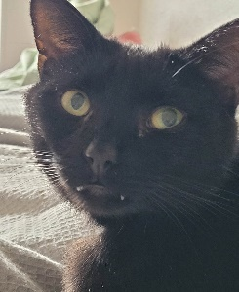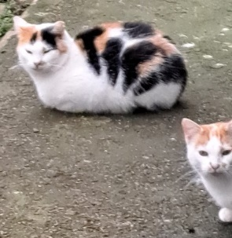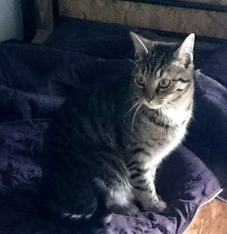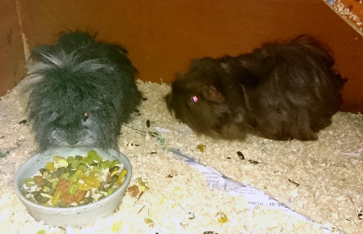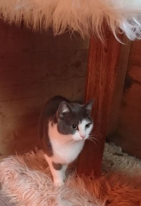

Other activities:
We can’t help all the animals but we try to assist as many as we can. Where we can’t actually bring them in, we try to help re-home them via our ‘Made in Heaven Matchmaking’ scheme. If the owners want to keep the animals but are struggling financially, we have our Pet Food Bank to help them. In addition to helping re-home domestic animals and supplying free pet food to pet owners we also assist feral cats in the community via our Project Wildcat Scheme
- Made In Heaven Matchmaking Scheme

Animals rehomed:
6 Dogs
2 Hamsters
8 feral cats
We also paid for any animals needing neutered and dog behaviorist support and arranged for all microchips details to be transferred to the new owners.
In addition, we advised / supported 8 people / families. 9 decided to keep their pet following our support.

Our free ‘Made in Heaven’ Matchmaking Service offers owners who are concerned where their dog will end up the chance to become more involved in the re-homing process. Ultimately, they have the choice of where their pets are going to be homed whilst holding on to them in their own home environment until that is achieved. This not only helps the animal by preventing them becoming stressed in kennels but also helps the owner get peace of mind. We have helped a substantial amount of owners work through their issues and helped changed their mind and decide to keep their pet after discussing their options or problems with us and taking the advice or support we offer, including the help of a dog behaviorist and paying for the cost of neutering. We continue to receive extremely positive feedback from those who used this service that this service alleviates stress from them being able to choose the new owner, the new owner can find out the history of the animal and everyone is happy with the level of support we have provided to them throughout.

This service continues to help towards promoting responsible animal ownership. It is also proving a very effective alternative in helping the public rehome during the crisis, especially when requests to rehome substantially increased & prevented overcrowding in sanctuaries.

- Pet Food Bank

We delivered 222 pet food provisions to people in crisis during 2022/23:
115 dogs
100 cats
2 rabbits
4 Guinea pigs
1 Ferret
All received a substantial amount of free pet food.

We also continued to receive requests for repeat supplies of food: 45 repeat requests providing pet food to 12 people requiring additional help up to 3 times.

69 people / families with pets received at least a month’s supply of pet food.

The pet food supplies were provided through donations to our pet food banks and groups (below) and from compassionate individuals.

7th Heaven paid an extra £287.71 for extra pet food, or special food in exceptional circumstances.

Our Pet Food Bank is designed to support people in financial hardship and distress by providing free pet food to enable them to hold onto their pets. This means they don’t have to endure the stress of seeing their animal suffer distress by being put into kennels or pounds. We always assess each person’s requirements individually.
Last year we continued to support an unprecedented number of the public needing urgent help - people who were ill, affected by the cost of living crisis, people whose income immediately stopped and delays in benefit / scheme claims. We are in contact with over 49 organisations supporting the public who now advise or refer people in need to us for pet food support.
Unfortunately, due to the reduction & irregular supplies of pet food donated, the spike of people needing urgent help due to the cost-of-living crisis, the substantial increase in pet food, some requests from people who either had just got a young animal knowing they were not able to afford it and people not being there just after we arranged the delivery, we had to review the pet food bank conditions on 9 March 2022:
- We will continue to provide pet food bank supplies to those in urgent need.
- We will prioritise those most in need.
- We will be restricting food to first time requests, with additional requests by exception & on a case-by-case basis.
- This will be dependent on the limited supplies we have and limited resources to do deliveries.
- We will aim to arrange deliveries in the same direction.
- We cannot guarantee any specific type of pet food as we are sharing out what has been donated to us
Some additional conditions:
- We won't leave pet food unattended or with anyone other than the person
- If the person is not in when we deliver, they will not receive any further deliveries (if it is due to an emergency and they have informed us themselves, we may make an exception)
- The pet food bank scheme is only there to provide temporary support during times of financial distress to enable the person to keep their pet, rather than having to rehome him/her. It is not to replace the owner providing pet food to their pet. If help is required ongoing, for a long time, then we may offer support to help rehome the animal, as we must think of his/her wellbeing.
- We also do not provide help to someone if they have got a new pet when they know they are struggling, as we need to encourage animal responsibility.

We have a Pet Food Bank donation point in Sainsbury’s Forestside. Sainsbury’s staff and customers are amazingly supportive. However, although this continues to be a success providing pet food & treats to all in need through our Pet Food Bank and Project Wildcat schemes, donations to this scheme have dropped by almost £3000 during the year and have been irregular, affecting the amount we can help, although we do pay for some through our own funds.

We are grateful to all the other companies, their customers and staff and public who also helped by various donations, especially during these difficult times.

Estimated value of pet food / vouchers donated 2022 / 2023:

Sainsbury’s Forestside £1782.05
Pets at Home VIP vouchers £1797.98
Tescos, Ballygomartin, Belfast (food &vouchers) £742.03
Purina £40.00
Fay & John £400.00
Total £4762.06

We also received donations of pet food from individuals including Alice, Maureen,Alicia/Peter, Judith, Yvonne, Whitehead Community, Audrey/David, Pat/Ethel, Dibbles Cat sitting service, Kathyn, Edgar & Christmas Tree farm and Grant Gipson.
Here’s some of the donations received:

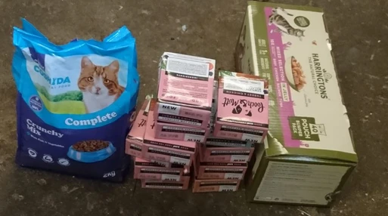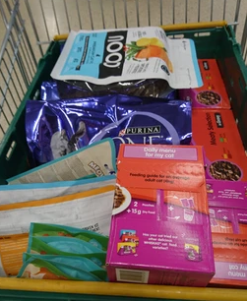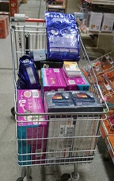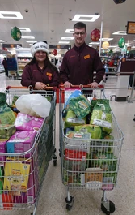
Grant Gipson family Tesco Ballygomartin Pets at Home / VIP Sainsbury Forestside

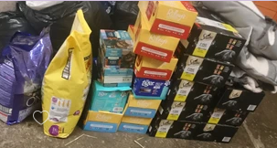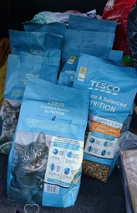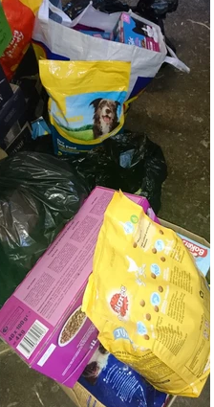
Fay, John & Geraldine Maureen Judith

We have shared out all this pet food, delivering it to pets whose owners are in need, and those helping feed the feral and community cats throughout Northern Ireland.
We provide regular updates on our website and Face book pages - 7th Heaven Animal Rescue Trust and Seventh Heaven, both on the pets helped and the donations gratefully received.
We would like to thank everyone who donated pet food to help feed them throughout the year. You are helping keep pets in their owner’s homes and prevented all these animals needing to be re-homed. We would also like to especially thank Community Advice, Antrim & Newtownabbey, Royal British Legion and other organisations for their numerous, necessary referrals to us.
Here’s some of the pets we helped:
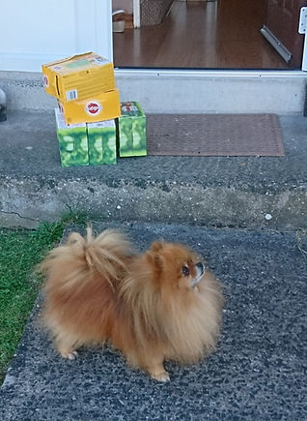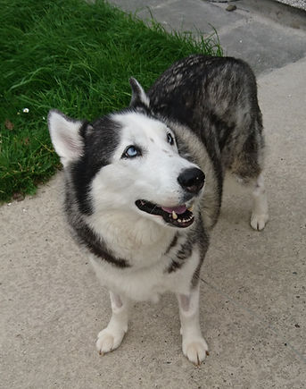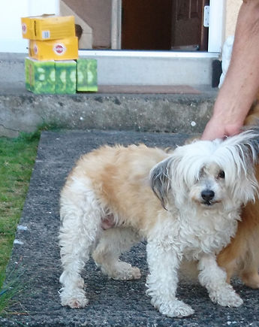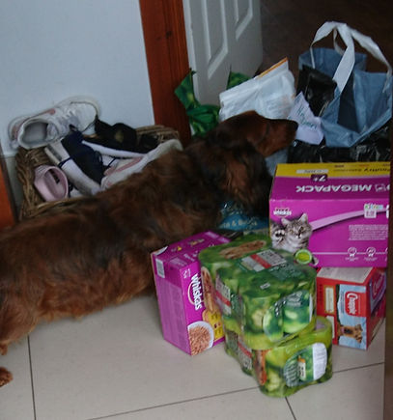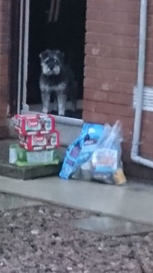

- Project Wildcat Scheme and Feral Cat Month

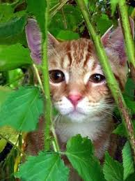

Shelter:
6 Plastic, waterproof Snugs were given out free of charge to provide safe, dry homes to 14 feral / community cats.

Neutering:
We paid for 2 feral cat to be neutered & 8 ill ferals treated.

Feeding:
We delivered 626 pet food provisions for feral/community cats through our Project Wildcat during 22/23. All received a substantial amount of free pet food.
324 feral cats received repeat supplies of food up to 7 times.

39 individuals, families or community groups were supplied with pet food to help the feral cats for which they were caring.

The pet food supplies were provided through donations to our pet food bank, and from groups and compassionate individuals.

7th Heaven paid an extra £1375.26 to support this scheme.

Project Wildcat was set up to help feral cats and those who care for them by providing free shelter, neutering and food. We had identified quite some time ago that there were a large number of feral cat colonies throughout Northern Ireland and, although many were being fed by volunteers or local people, the cost to them was substantial. Many more cats are neutered by other Trap, Neuter and Return individuals who contact us to provide shelter and food after this has been done.

Due to the unprecedented requests for support throughout Northern Ireland, we availed of ASDA, Tesco & Sainsbury click & collects/deliveries to reach the public further away or who may need supplies urgently.

Although we feed the ferals all year round we also highlight their plight by designating October as ‘7th Heaven’s Feral Cat Month’. We did not cancel this event despite the crisis. We delivered good supplies of pet food to 8 individuals/groups feeding 88 feral/community cats.

From the positive feedback and support we have received about Project Wildcat scheme and Feral Cat Month, they are a major success. We are the only people in Northern Ireland who provide this service and the obvious need for it means we will continue to help feral/community cats as part of our core services.

Here’s some of the cats supported and shelters and pet food provided:

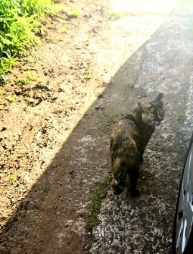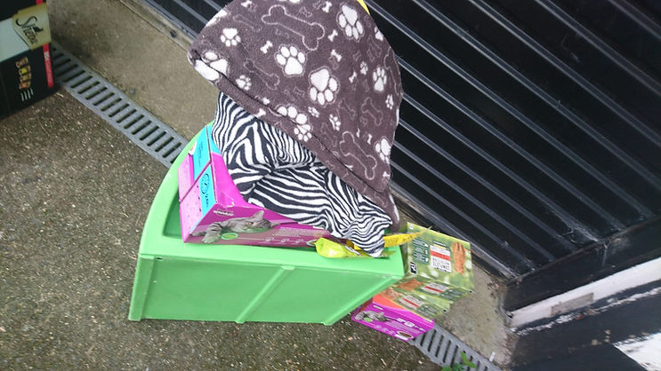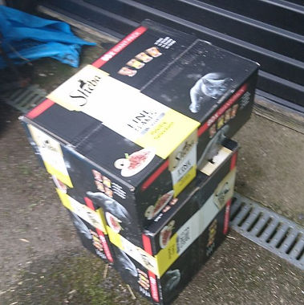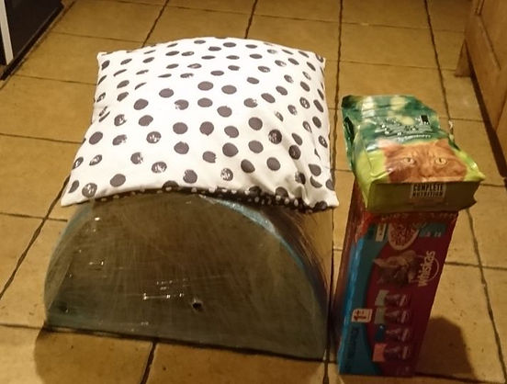

We delivered 848 pet food provisions for animals in both schemes during 2022/23.

- Pet Friendly Landlord Scheme

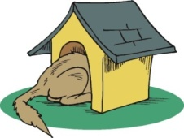

7th Heaven continues to see a huge increase in people having to give up their pets when they move to new accommodation. Landlords continue to be reluctant to let pets stay in their accommodation and many who do, charge extra insurance, which many tenants cannot afford. This forces people to give up their beloved pets when their circumstances are beyond their control.
We set up the Pet Friendly Landlord Scheme in 2015/16 to help pet owners in this difficult situation and had contacted the majority of those involved with landlords, including councils, associations and central bodies to ask if there was anything, they would be willing to do to help. Although we received only minimal response, we continue to offer free advertising to any landlord willing to offer a home to a pet owner. We continue to support the public to prevent them having to give up their pets in these unfortunate circumstances and encourage landlords to see the benefits.
There’s nothing more special than being able to help keep pets with their owners in their homes!
- Daisy Day
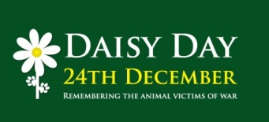

7th Heaven designated the 24th December as Daisy Day – a time to remember all the animals killed and injured in war. We have chosen the daisy as it symbolises innocence and, like the animal victims of war, they are numerous and always overlooked. We want everyone to say a prayer or spare a thought for the innocent animal victims of human war at this traditional time of peace.
On the 24th December each year now and on the days leading up to it, we ask everyone if they could like and share our Daisy Day face book page and encourage others to do so. We are hoping, maybe, that we could create a better awareness of their plight and by everyone on this day thinking of those animals taken from us by man’s conflicts, we could create a ‘daisy-chain’ of compassion, our thoughts, the links of love, joining us all together, across borders, race and religion. Maybe we could create a world where man no longer solves disputes by force or resolves differences by weapons. Maybe then the animals will stop suffering and dying at our hands. We ask that you please spare a moment to remember them.
- Finance
Income raised £6494.96
Payments £11061.18
Balance - £4566.22
Cash Funds brought forward: £64224.06
Funds at 31/3/2022 £59657.84

Income raised:

Grants/ fundraising
No grants received this year.

Sainsbury’s

We continue to receive pet food donations from kind customers through our donation point set up in-store in Forestside, which is helping both the Food Bank and Project Wildcat schemes.
We would like to thank Sainsbury’s customers for their generosity throughout the year and to Sainsburys and their staff for making this possible.

Tesco, Ballygomartin
Tesco, Ballygomartin continue to support us throughout the year with pet store collections & vouchers (£407.09).

Pets at Home
Pets at Home, Support Adoption for Pets and VIP Club and their customers have supported our charity throughout the year. We received £1797.98 VIP Lifeline vouchers which we used to buy pet food supplies to support our Pet Food Bank/ Project Wildcat schemes and new equipment for the animals in our care.

E-Bay / PayPal Giving/ Amazon Smile
The funds of £280.90 from E-Bay sales, Humble Bundle donations from PayPal Giving Fund and Amazon Smile have provided significant contribution towards income raised, with several individuals regularly donating each month.
This was particularly important as all our other fundraising activities had reduced during this time. We would like to thank everyone who donated funds from their sales, items for selling through our E-Bay charity site and for on-going regular support through PayPal Giving.

Friendship Scheme and Shelter Sponsorship
We have 28 Special Friends / members who continue to support our charity each month; 31 others who continue to donate both large and small amounts each year including 2 who specifically sponsor our kennels and long-term residents.

Events
Several events during the year raised £495.28: May Day Fair -Susan & Vic; Tesco Ballygomartin store collections; Dibbles Cat Sitting – selling Christmas Calendars and Christmas Tree Farm collection.
Our thanks to all concerned.

Others support:
We have other ways to raise funds and help our charity including (details are on our website):
- Amazon Wish List
- Ebay / Paypal Giving Fund
- Give as You Live
- Payroll Giving in Action
- Charities Aid Foundation
- Pets at Home VIP Club Lifelines
Since joining these organisations for free, we have started to receive donations from the public, interested in supporting our charity. We are grateful as this has helped to provide us with a further supply of funds to help those in need

Payments out:
We will make no personal profit from an animal’s misery, which is why nobody involved in our charity gets paid. This is why there are no expenses for staff wages. Electricity bills rose substantially this year to £1430 (Sept – March as Trustees only charge actual cost during winter months).

We paid out £1454.70 for vet treatment for a FIP & disabled cat fostered by TC’s Forever Home. We were delighted that the treatment has cured the FIP. They were supported by #fipwarrior & with Donard vets monitoring all the way.

Project Wildcat costs of £1375.26 was used for the purchase extra pet food and helped with neutering and vet cast for some ill ferals. The cost for this scheme is mainly due to the amount of ferals cats we help, the reduction in pet food donations due to the cost of living crisis and the fact that we are the only animal charity providing this support in Northern Ireland. We could not stop providing this essential crisis as animals’ lives depended upon this and many of the public caring for them were in significant financial difficulty.

Pet food Bank costs of £287.71 related to ongoing urgent requests for help especial during times of crisis. We were extremely proud that we were able to continue to help the public during this exceptional time and even extend it to those directly affected by the impact of the Covid 19 & Cost of Living crisis and ongoing illness.

We had already set up click & collect arrangements with Asda, Tescos and Sainsburys to order pet food for people in our schemes in times of emergency. This has become critical during the Covid and other times of illness / crisis to have this contingency in place.

We do all the promotion of 7th Heaven’s animals and the schemes ourselves. Administration costs are for the internet / website access and necessary IT upgrades (NB. there is no charge for the design or upkeep as this is provided by the trustees) and leaflets and business cards for the schemes and for events. We had suspended newsletters due to resources but continue to promote the work we do on Facebook, our website & in-store shops who support us.

- Thanks
We do not charge to take in or re-home any animal. As our motto states, “Animals are not commodities to be bought or sold. They are beautiful creatures with beautiful souls”. We are not their ‘owners’ merely their ‘guardians’ and, therefore, have no moral right to put a price tag on their head. This is why we do not and never will charge for our animals. Nor do we do not charge for any of our schemes or support we provide. We do not receive any government support. So we would particularly like to thank everyone who donated funds to 7th Heaven. This is important to our charity to help us provide everything necessary to help animals both in our care and people and animals supported through our schemes.

We would like to acknowledge all the people who have helped us in other ways. We really appreciate the donations of pet food direct from individuals to feed our long term and elderly residents. We also once again started to receive supplies of bedding which the animals are especially appreciative of. This all helps keep our costs low. Thanks to all the good Samaritans out there who did not look the other way, but contacted us when they found a lost, ill or abandoned animal and many who provided a shelter for them until we could find room to take them in or a new home, especially when the weather was very bad, We would especially like to thank everyone who has offered each of our rescue animals a new chance and a loving home.

This continues to be an exceptional and difficult year for everyone. We had limited means to raise funds, no volunteer resource, just the Trustees who kept everything going from caring from the animals to delivering pet food and shelters. But amazingly we were able to provide almost 840 supplies of pet food during the year, helping people in real and significant need.

- Statement of Trustees' Responsibilities
The trustees are required to prepare financial statements for each financial year, which give a true and fair view of the state of affairs of the charity and of the incoming resources and application of resources of the charity for that period. In preparing these financial statements, the trustees are required to:
• select suitable accounting policies and then apply them consistently;
• make judgements and estimates that are reasonable and prudent;
• state whether applicable accounting standards have been followed, subject to any material departures disclosed and explained in the financial statements; and
• prepare the financial statements on the going concern basis unless it is inappropriate to presume that the charity will continue in business.
The trustees are responsible for keeping proper accounting records that disclose with reasonable accuracy at any time the financial position of the charity and enable them to ensure that the financial statements comply with the Charities Act. The trustees are also responsible for safeguarding the assets of the charity and hence for taking reasonable steps for the prevention and detection of fraud and other irregularities.
The Trustees declare that they have approved the trustees’ report above
Signed on behalf of the charity’s trustees:
Stephen McMurray
Trustee/ Treasurer
8 January 2024

